SOTJ 2024 Summary results

Considerations regarding the sample and estimates to use
- In general, our data consists of a relatively small but increasing number of reporting countries. However, many of them include values in aggregate groups, such as “Rest of the World” or “Other Africa,” instead of specific countries.
- We can consider three samples to work with:
- We can use only the actual country-by-country data we have from reporting countries. This data is relatively accurate but disregards information reported on aggregated groups (which often include tax havens) and information from MNEs registered in non-reporting countries.
- We can use all reporting countries and distribute the “aggregate” categories to actual countries while ensuring their sum totals the aggregate value. This approach allows us to utilize all information we have in the CbCR data but disregards information from MNEs registered in non-reporting countries.
- We can use all reporting countries and distribute the “aggregate” categories to actual countries while predicting values for non-reporting countries through statistical analysis. This approach brings us closer to a “global” estimate but is highly sensitive to the quality of the predictions. Additionally, it is somewhat odd to predict both profit and economic activity and then claim that they do not match, as we do in the misalignment method.
- I report the results of all samples below. For those including predictions, we could use multiple samples with different predictions (bootstrapping). This is included in the notebooks, but here I only use one sample as I did not have enough time for bootstrapping. The results do not vary significantly across bootstrapped samples.
- In general, if we want to obtain a global estimate, I believe the best way is NOT to predict all the data but to calculate profits shifted as a share of total profits for our sample (either from sample 1 or sample 2). We can then estimate a rough global figure by simply multiplying global MNE profits with that share. I still think this estimate would be more accurate than the one based on the imputation procedure.

Open issues
- We use Orbis data to determine which country should report on CbCR (i.e. has at least Global Ultimate Owner (GUO) above the revenue threshold). However, this Orbis data is quite old and I do not know where it comes from. So far, I have included only countries that report at least two GUOs, as we get super high estimates for a few countries (like Liberia) otherwise. If we can improve the Orbis data, we should set that back to requiring only one GUO.
- The tax revenue data in the current sample should be double checked, especially for 2017. It seems that there is a problem/outliers there.
- It might also make sense to double check the health expenditure data.
- In general, all country-level results need to be double checked to ensure they all exist and have plausible values.
- Minor: The figures created in the 4_figures notebook are not stored anywhere so far, I just copy pasted them here.

Data quality over time
- While the number of reporting countries has increased over time from 26 to 52, only 39 countries report data that is actually useful in 2021. The remaining 13 countries either just report variables for themselves and an aggregated “rest of the world” category, or report for themselves and aggregated continents.
Year | Reporting countries | Reporting countries with useful data | Countries that only report variables for themselves and the "rest of the world" |  | Countries that only report variables for themselves and aggregated continents
2016 | 26 | 19 | 4 | Finland, Ireland, Korea, Netherlands | 3 | Austria, Norway, Sweden
2017 | 38 | 28 | 4 | Finland, Ireland, Korea, Netherlands | 6 | Austria, Greece, Isle of Man, Norway, Sweden, UK
2018 | 46 | 36 | 5 | Finland, Hungary, Ireland, Korea, New Zealand | 5 | Austria, Greece, Isle of Man, Sweden, UK
2019 | 50 | 36 | 5 | Czechia, Hungary, Ireland, Macau, New Zealand | 9 | Austria, Finland, Greece, Korea, Isle of Man, Mauritius, Poland, Sweden, UK
2020 | 52 | 39 | 5 | Czechia, Hungary, Ireland, Macau, New Zealand | 8 | Austria, Finland, Korea, Isle of Man, Mauritius, Poland, Sweden, UK
2021 | 52 | 39 | 6 | Czechia, Hungary, Ireland, Macau, Morocco, New Zealand | 7 | Austria, Finland, Korea, Mauritius, Poland, Sweden, UK

Results based on actually reported data

When basing our analysis on “Reporting countries with useful data” only, we get the following results with the SOTJ formula (0.5 employment, 0.5 payroll)
 | Shifted profits |  | Tax revenues lost |  | Tax revenue gained in  Million USD
 | Million USD | % of reported profits | Million USD | % of government health expenditure
2016 | 391,468 | 17.5% | 107,773 | 7% | 23,045
2017 | 785,579 | 17.9% | 214,290 | 14% | 47,105
2018 | 704,731 | 13.9% | 187,756 | 23% | 45,671
2019 | 898,450 | 17.1% | 234,335 | 37% | 65,514
2020 | 817,911 | 21.7% | 200,386 | 25% | 55,051
2021 | 1,133,582 | 14.6% | 275,917 | 39% | 69,099

Results look similar for different formulas
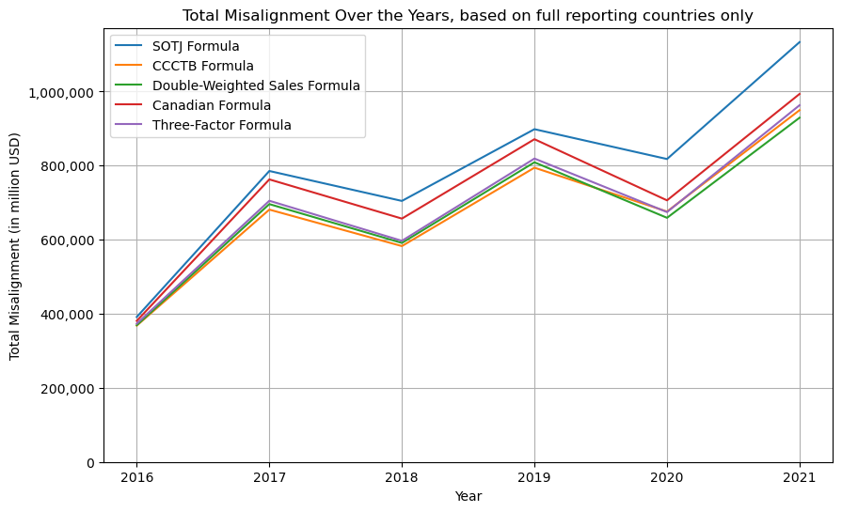
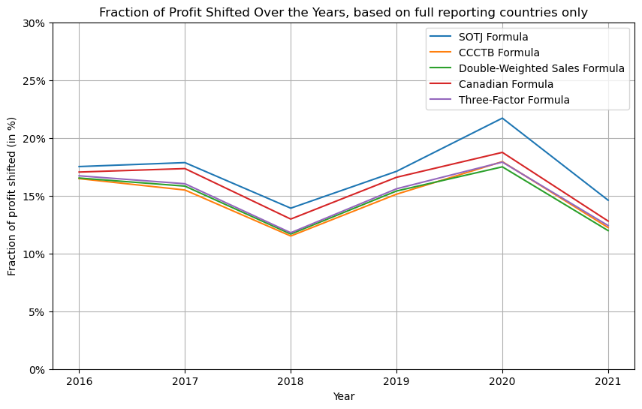
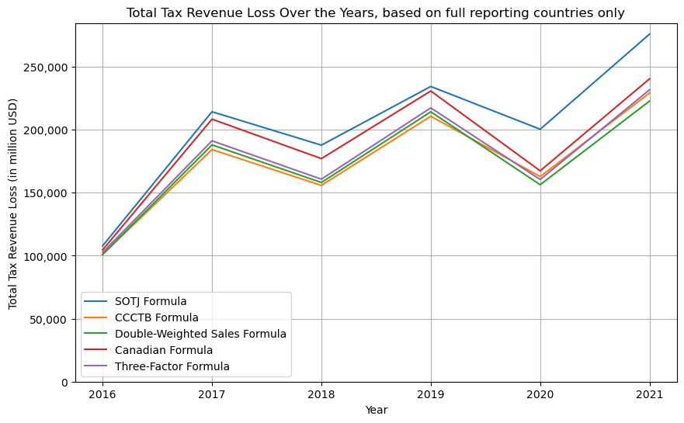
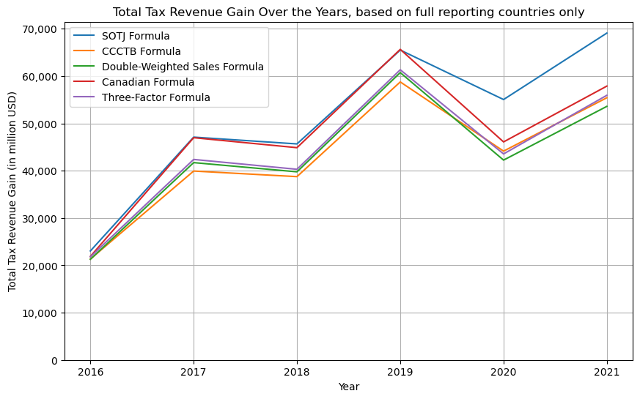

Results based on actually reported data and imputed values for existing reporting countries’ aggregate values

Results based on the SOTJ formula are reported in the table below
 | Shifted profits |  | Tax revenues lost |  | Tax revenue gained in  Million USD
 | Million USD | % of reported profits | Million USD | % of government health expenditure
2016 | 703,438 | 22.4% | 192,929 | 21.7% | 31,579
2017 | 1,412,380 | 19.6% | 383,138 | 93.4% | 79,211
2018 | 1,778,827 | 21.5% | 466,819 | 46.2% | 90,501
2019 | 1,961,210 | 23.6% | 505,389 | 173.3% | 107,626
2020 | 2,259,881 | 38.6% | 563,083 | 187.9% | 100,934
2021 | 2,567,033 | 21.8% | 642,308 | 433.0% | 123,275

Results look similar for different formulas
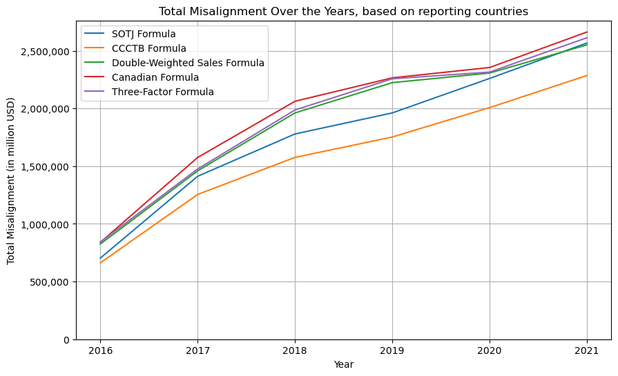
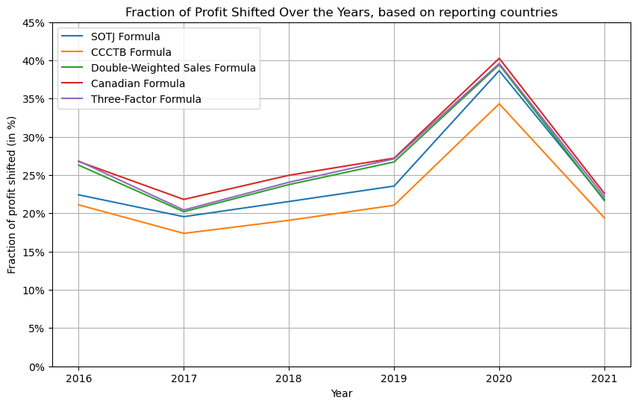
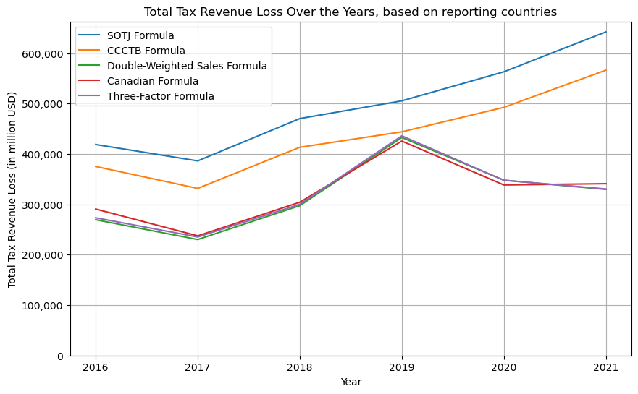
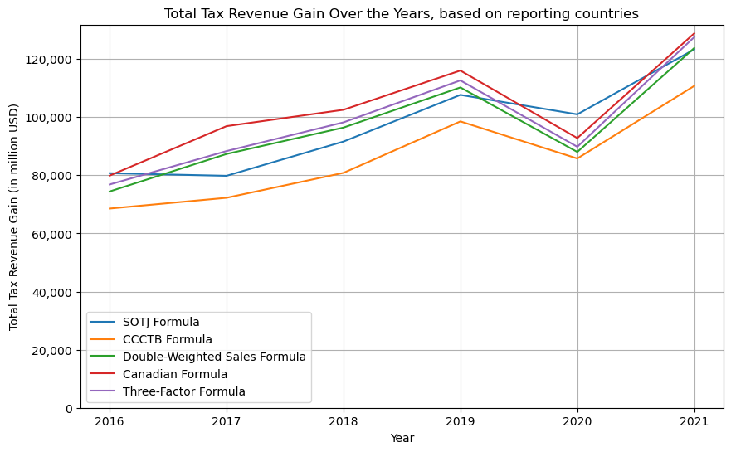

Results based on actually existing data and imputed data for all countries with multinationals above the reporting threshold

Results based on the SOTJ formula are reported in the table below
 | Shifted profits |  | Tax revenues lost |  | Tax revenue gained in  Million USD
 | Million USD | % of reported profits | Million USD | % of government health expenditure
2016 | 932,052 | 17.6% | 250,439 | 33.7% | 45,413
2017 | 1,437,417 | 17.0% | 389,402 | 96.5% | 80,642
2018 | 1,852,198 | 21.6% | 484,853 | 47.8% | 95,761
2019 | 1,963,585 | 23.1% | 505,910 | 173.3% | 107,790
2020 | 2,260,059 | 38.4% | 563,123 | 187.9% | 100,945
2021 | 2,598,109 | 21.3% | 649,496 | 435.9% | 125,466

Results look similar for different formulas
